

Practical No. : 4
Aim –
Use JavaScript function types, scope, closures; apply try-catch; build a palindrome checker.
Software/Tools Required –
- VSCode,
- Chrome,
- HTML5,
- CSS3,
- Javascript (ES6)
Experiment Program Code –
index.html

<!DOCTYPE html>
<html lang="en">
<head>
<meta charset="UTF-8">
<meta name="viewport" content="width=device-width, initial-scale=1.0">

<title> Palindrome Checker </title>

<link href="https://fonts.googleapis.com/css2?family=Cinzel:wght@700&family=Poppins:wght@300;400;500;600&display=swap" rel="stylesheet">

<style>

*{
margin:0;
padding:0;
box-sizing:border-box;
font-family:'Poppins',sans-serif;
}

body{
display:flex;
justify-content:center;
align-items:center;
min-height:100vh;
background:#050505;
overflow:hidden;
position:relative;
}

body::before{
content:"";
position:absolute;
width:500px;
height:500px;
background:#7d0000;
border-radius:50%;
filter:blur(180px);
top:-150px;
left:-150px;
opacity:.45;
}

body::after{
content:"";
position:absolute;
width:450px;
height:450px;
background:#b30000;
border-radius:50%;
filter:blur(170px);
bottom:-150px;
right:-150px;
opacity:.35;
}

.container::before{

content:"";
position:absolute;
top:-18px;
left:25px;
font-size:34px;

}

.container::after{

content:" ";
position:absolute;
top:-18px;
right:25px;
font-size:34px;

}

.container:hover{

transform:translateY(-8px);

box-shadow:
0 0 25px crimson,
0 0 80px rgba(255,0,0,.25);

}

.container::before{

content:" ";
position:absolute;
top:-18px;
left:25px;
font-size:34px;

}

.container::after{

content:" ";
position:absolute;
top:-18px;
right:25px;
font-size:34px;

}

h2{

font-family:'Cinzel',serif;
text-align:center;
color:#ff2b2b;
font-size:32px;
letter-spacing:2px;

}

.subtitle{

color:#8f8f8f;
text-align:center;
margin:15px 0 30px;

}

input{

width:100%;
padding:15px;

background:#111;

color:white;

border:2px solid #330000;

border-radius:12px;

outline:none;

transition:.35s;

font-size:15px;

}

input::placeholder{

color:#777;

}

input:focus{

border-color:#ff0000;

box-shadow:0 0 20px rgba(255,0,0,.4);

}

button{

width:100%;

margin-top:22px;

padding:15px;

border:none;

border-radius:12px;

background:linear-gradient(135deg,#4d0000,#ff1c1c);

color:white;

font-size:17px;

font-weight:600;

cursor:pointer;

transition:.35s;

}

button:hover{

transform:translateY(-3px);

letter-spacing:2px;

box-shadow:0 0 20px crimson;

}

button:active{

transform:scale(.97);

}

#result{

margin-top:25px;

text-align:center;

color:white;

font-size:20px;

font-weight:bold;

min-height:30px;

}

.footer{

margin-top:25px;

text-align:center;

color:#666;

font-size:12px;

}

</style>

</head>

<body>

<div class="container">

<h2>PALINDROME CHECKER</h2>

<p class="subtitle">
Check whether your text is a palindrome.
</p>

<input
type="text"
id="text"
placeholder="Enter your text..."
>

<button onclick="checkPalindrome()">
CHECK NOW
</button>

<p id="result"></p>

<div class="footer">
name:- Salim ANsari /24070521005
</div>

</div>

<script>

function checkPalindrome(){

try{

let text=document.getElementById("text").value;

if(text.trim()==""){

throw "Enter some text first ";

}

let original=text.toLowerCase().replace(/[^a-z0-9]/g,"");

let reverse=original.split("").reverse().join("");

if(original===reverse){

document.getElementById("result").innerHTML=" PALINDROME APPROVED ";

alert(" The approves this Palindrome!");

}

else{

document.getElementById("result").innerHTML="❌ Not a Palindrome!";
alert("Not a Palindrome.");

}
}
catch(error){
alert("❌ Error : "+error);

document.getElementById("result").innerHTML="⚠ "+error;

}

finally{

console.log("Palindrome Checker Executed");

}

}

</script>

</body>
</html>

Palindrome Checker A palindrome is a word or sequence that reads the same forwards and backwards. Examples:
Output –
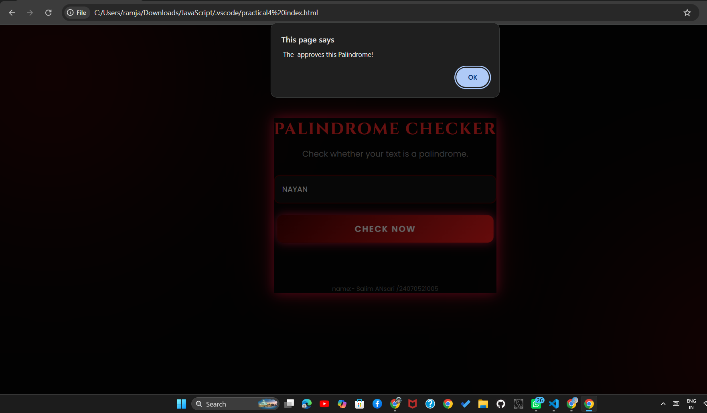
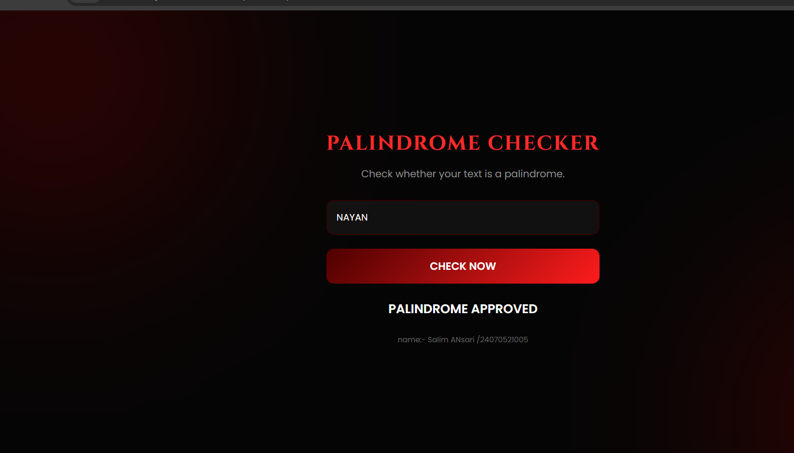

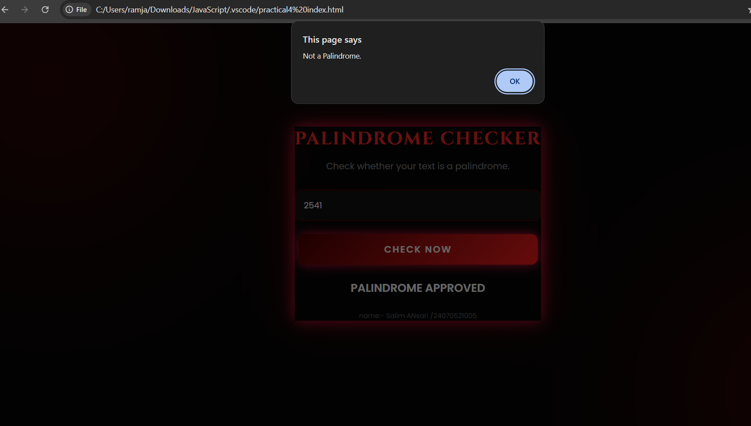
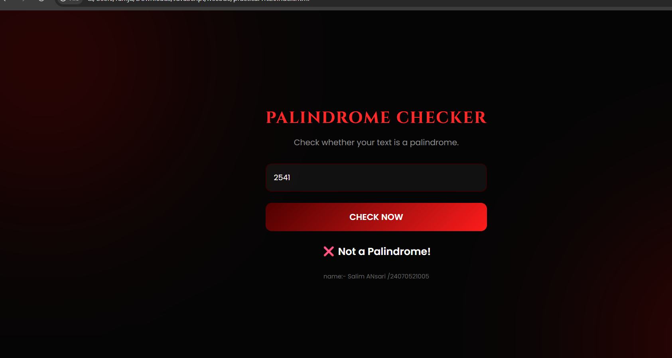

Case Study Title –
To develop a web application using HTML and JavaScript that validates a vehicle registration number using JavaScript functions and exception handling (try-catch) based on predefined validation rules, and displays whether the registration number is valid or invalid.
Case Study Program Code –
index.html
<!DOCTYPE html>
<html lang="en">
<head>
<meta charset="UTF-8">
<meta name="viewport" content="width=device-width, initial-scale=1.0">
<title>Vehicle Registration Validator</title>
<style>
:root {
--bg-dark: #0f172a;
--card-bg: #1e293b;
--accent: #38bdf8;
--accent-dark: #0ea5e9;
--success: #22c55e;
--error: #f87171;
--text-light: #e2e8f0;
--text-muted: #94a3b8;
--border: #334155;
}

* { box-sizing: border-box; }

body {
margin: 0;
min-height: 100vh;
display: flex;
flex-direction: column;
align-items: center;
justify-content: center;
background: linear-gradient(135deg, #0f172a 0%, #1e293b 100%);
font-family: 'Segoe UI', Roboto, Helvetica, Arial, sans-serif;
color: var(--text-light);
padding: 20px;
}

.card {
background: var(--card-bg);
border: 1px solid var(--border);
border-radius: 16px;
padding: 36px 32px;
width: 100%;
max-width: 440px;
box-shadow: 0 20px 50px rgba(0,0,0,0.4);
}

.card h1 {
font-size: 22px;
margin: 0 0 4px;
text-align: center;
color: var(--text-light);
}

.card p.subtitle {
text-align: center;
color: var(--text-muted);
font-size: 13px;
margin: 0 0 24px;
}

label {
display: block;
font-size: 13px;
color: var(--text-muted);
margin-bottom: 8px;
}

.input-row {
display: flex;
gap: 10px;
}

input#regInput {
flex: 1;
padding: 12px 14px;
font-size: 16px;
letter-spacing: 1.5px;
text-transform: uppercase;
background: #0f172a;
border: 1px solid var(--border);
border-radius: 8px;
color: var(--text-light);
outline: none;
transition: border-color 0.2s, box-shadow 0.2s;
}

input#regInput::placeholder {
letter-spacing: normal;
text-transform: none;
color: #64748b;
}

input#regInput:focus {
border-color: var(--accent);
box-shadow: 0 0 0 3px rgba(56, 189, 248, 0.15);
}

button {
padding: 12px 20px;
font-size: 14px;
font-weight: 600;
background: linear-gradient(135deg, var(--accent) 0%, var(--accent-dark) 100%);
color: #0f172a;
border: none;
border-radius: 8px;
cursor: pointer;
transition: transform 0.1s, opacity 0.2s;
}

button:hover { opacity: 0.9; }
button:active { transform: scale(0.97); }

.format-hint {
margin-top: 12px;
font-size: 12px;
color: var(--text-muted);
line-height: 1.6;
background: rgba(56, 189, 248, 0.06);
border: 1px solid rgba(56, 189, 248, 0.2);
border-radius: 8px;
padding: 10px 12px;
}

.format-hint code {
color: var(--accent);
font-weight: 600;
}

#result {
margin-top: 20px;
padding: 14px 16px;
border-radius: 10px;
font-size: 14px;
line-height: 1.5;
display: none;
animation: fadeIn 0.25s ease;
}

@keyframes fadeIn {
from { opacity: 0; transform: translateY(-4px); }
to { opacity: 1; transform: translateY(0); }
}

#result.show { display: block; }

#result.success {
background: rgba(34, 197, 94, 0.12);
border: 1px solid rgba(34, 197, 94, 0.4);
color: #86efac;
}

#result.error {
background: rgba(248, 113, 113, 0.12);
border: 1px solid rgba(248, 113, 113, 0.4);
color: #fca5a5;
}

#result strong {
display: block;
margin-bottom: 4px;
font-size: 14px;
}

.breakdown {
margin-top: 10px;
font-size: 12px;
color: var(--text-muted);
}

.breakdown span {
display: inline-block;
background: #0f172a;
border: 1px solid var(--border);
border-radius: 6px;
padding: 3px 8px;
margin: 3px 4px 0 0;
}
.footer {
margin-top: 20px;
text-align: center;
color: #94a3b8;
font-size: 14px;
}

.footer strong {
color: #38bdf8;
}

.footer strong {
color: #38bdf8;
}

.footer strong {
color: #38bdf8;
}
</style>
</head>
<body>

<div class="card">
<h1>🚗 Vehicle Registration Validator</h1>
<p class="subtitle">Validate a vehicle registration number format</p>

<label for="regInput">Enter Registration Number</label>
<div class="input-row">
<input type="text" id="regInput" placeholder="e.g. MH12AB1234" maxlength="10">
<button id="validateBtn">Validate</button>
</div>

<div class="format-hint">
Format: <code>SS DD SS DDDD</code> — 2 State letters, 2 District digits,
2 Series letters, 4 Vehicle digits (exactly 10 characters, e.g. <code>MH12AB1234</code>).
</div>

<div id="result"></div>
</div>

<footer class="footer">
Created by <strong>Salim Ansari/24070521005</strong>
</footer>

<script>
const regInput = document.getElementById('regInput');
const validateBtn = document.getElementById('validateBtn');
const resultBox = document.getElementById('result');

class ValidationError extends Error {
constructor(message) {
super(message);
this.name = 'ValidationError';
}
}

function validateRegistrationNumber(regNo) {
if (regNo === null || regNo === undefined || regNo.trim() === '') {
throw new ValidationError('Registration number cannot be empty.');
}

const value = regNo.trim().toUpperCase();
if (value.length !== 10) {
throw new ValidationError(
`Registration number must be exactly 10 characters long (you entered ${value.length}).`
);
}
const stateCode = value.substring(0, 2);
const districtCode = value.substring(2, 4);
const series = value.substring(4, 6);
const vehicleNumber = value.substring(6, 10);

const alphaPattern = /^[A-Z]{2}$/;
const digitPattern2 = /^[0-9]{2}$/;
const digitPattern4 = /^[0-9]{4}$/;

if (!alphaPattern.test(stateCode)) {
throw new ValidationError(
`First 2 characters must be uppercase alphabets (State Code). Found "${stateCode}".`
);
}
if (!digitPattern2.test(districtCode)) {
throw new ValidationError(
`Characters 3-4 must be digits (District Code). Found "${districtCode}".`
);
}
if (!alphaPattern.test(series)) {
throw new ValidationError(
`Characters 5-6 must be uppercase alphabets (Series). Found "${series}".`
);
}
if (!digitPattern4.test(vehicleNumber)) {
throw new ValidationError(
`Last 4 characters must be digits (Vehicle Number). Found "${vehicleNumber}".`
);
}
return { value, stateCode, districtCode, series, vehicleNumber };
}
function showResult(type, html) {
resultBox.className = 'show ' + type;
resultBox.innerHTML = html;
}
function handleValidate() {
const rawValue = regInput.value;
try {
const parsed = validateRegistrationNumber(rawValue);

showResult('success', `
<strong>✅ Valid Registration Number</strong>
"${parsed.value}" follows the required format.
<div class="breakdown">
<span>State: ${parsed.stateCode}</span>
<span>District: ${parsed.districtCode}</span>
<span>Series: ${parsed.series}</span>
<span>Number: ${parsed.vehicleNumber}</span>
</div>
`);
} catch (err) {
if (err instanceof ValidationError) {
showResult('error', `<strong>❌ Invalid Registration Number</strong>${err.message}`);
} else {

showResult('error', `<strong>⚠️ Unexpected Error</strong>${err.message}`);
}
}
}
validateBtn.addEventListener('click', handleValidate);
regInput.addEventListener('keyup', (e) => {
if (e.key === 'Enter') handleValidate();
});
</script>
</body>
</html>

Output –
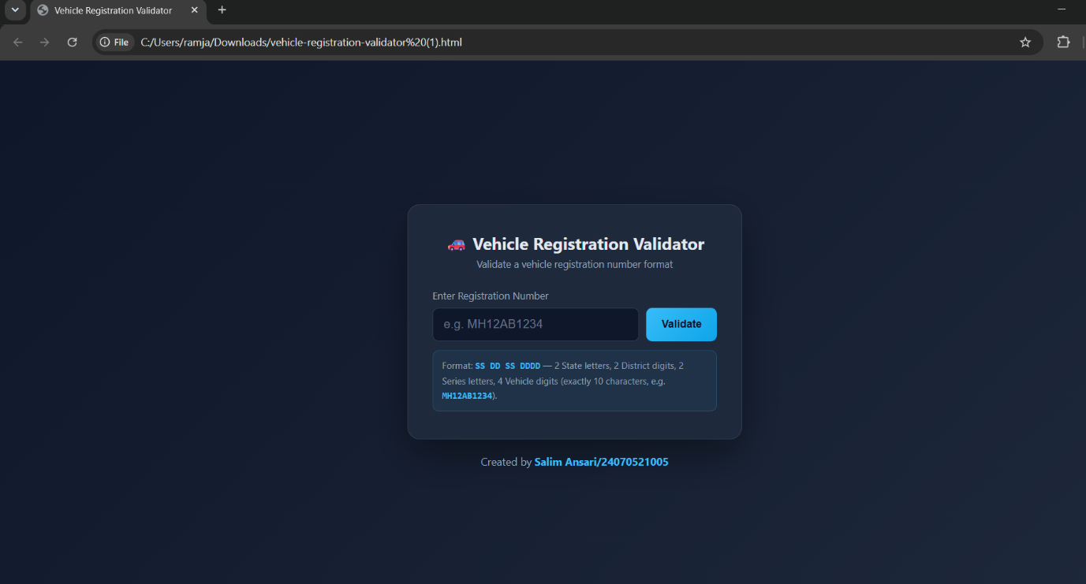
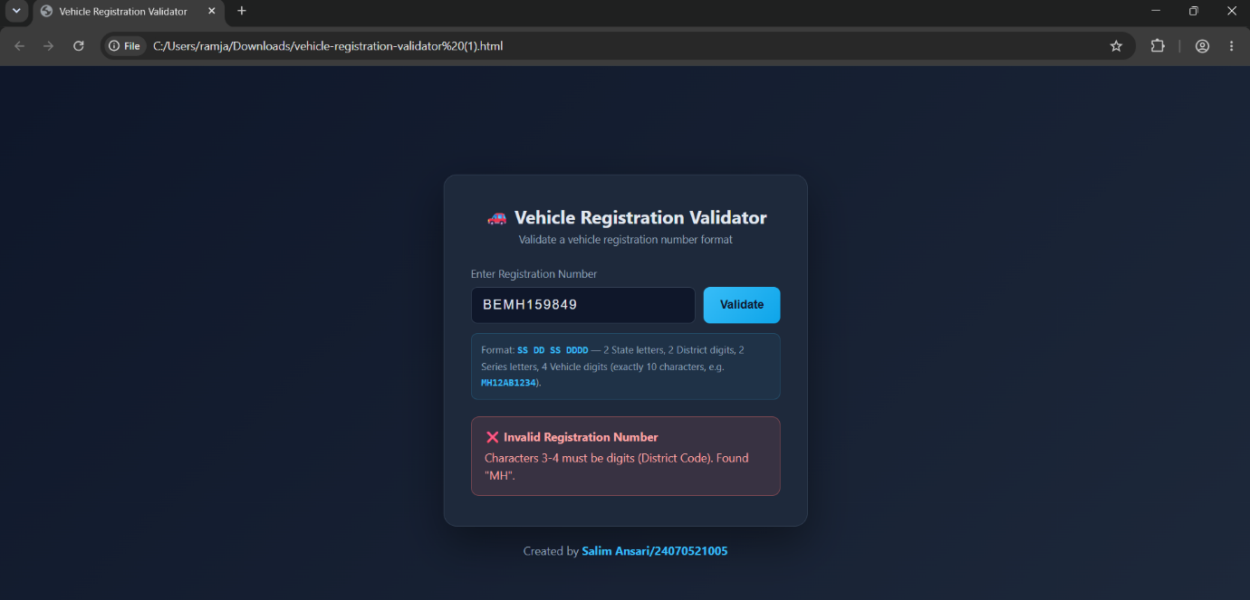
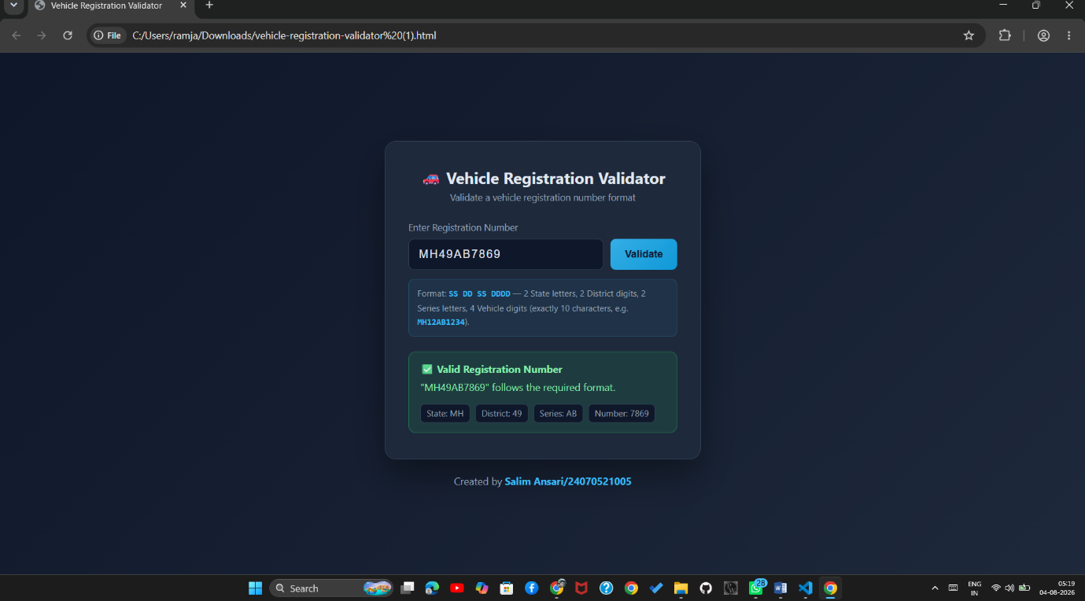
Conclusion –
The experiment was successfully performed to understand JS functions, variable scope, closures, and exception handling using try-catch. A Vehicle Registration Validator and a Palindrome Checker were developed, these applications demonstrated input validation, string manipulation, and error handling using JavaScript.

